1. Project Title: PowerPulse: AI-Driven Energy Consumption & Cost Optimization
2. Project Statement and Outcomes:
Households and small businesses often lack clear visibility into their energy consumption patterns, the financial impact of inefficiencies, and the practical steps available to reduce utility bills through smarter usage or eco-friendly alternatives. This project builds a full-stack AI-powered energy management web application that ingests utility bill data, smart meter readings, and appliance usage logs to model consumption patterns, identify inefficiencies, and calculate current utility expenses. The system presents eco-friendly alternative solutions — including solar panel adoption, energy-efficient appliance upgrades, and behavioral changes — with a detailed ROI projection engine that shows users their expected payback period and long-term savings for each recommended action.
The deliverable is an energy intelligence portal where users upload utility bills or connect smart meter APIs, view AI-generated consumption analysis, and receive ranked eco-friendly recommendations complete with investment cost, projected savings, ROI timeline, and environmental impact metrics. A financial projection dashboard, bill comparison tool, and downloadable savings report will help users make evidence-based decisions about transitioning to sustainable energy solutions.
3. Modules to be Implemented:
- Energy Data Collection & Utility Bill Integration
- ML Consumption Analysis & Forecasting Engine
- Eco-Alternatives, ROI Engine & Energy Dashboard
- System Integration, Testing & Project Finalization
4. Week-wise Module Implementation and High-Level Requirements:
Weeks 1–2: Energy Data Collection & Utility Bill Integration
- Build a utility bill upload pipeline supporting PDF and image formats; implement OCR (Tesseract/AWS Textract) to extract consumption units, billing amount, and tariff data.
- Integrate smart meter data APIs for granular hourly or daily consumption data streams.
- Design an appliance usage questionnaire module allowing users to declare major appliances, usage hours, and star ratings for consumption modeling.
- Set up a tariff database covering major regional electricity providers to enable accurate cost calculation from consumption data.
- Design the database schema for storing monthly bills, consumption timelines, and appliance profiles per user account.
Weeks 3–4: ML Consumption Analysis & Forecasting Engine
- Build a time-series consumption forecasting model (SARIMA, Prophet, LSTM) trained on user bill history to project future monthly and seasonal usage.
- Implement an anomaly detection module that flags unusual consumption spikes and attributes them to likely causes (seasonal, appliance fault, behavioral change).
- Develop a consumption decomposition engine that estimates the share of usage attributable to HVAC, lighting, appliances, and water heating.
- Build a baseline comparison module that benchmarks user consumption against similar household profiles (size, location, season).
- Serve analysis results via a FastAPI endpoint with structured consumption breakdown, forecast values, and anomaly flags.
Weeks 5–6: Eco-Alternatives, ROI Engine & Energy Dashboard
- Build an eco-friendly solution catalog covering solar panels, battery storage, LED retrofits, inverter ACs, and solar water heaters with market pricing data.
- Develop an ROI projection engine calculating payback period, net savings over 5/10 years, and monthly bill reduction for each recommended solution.
- Integrate government subsidy and incentive data (MNRE solar subsidies, state schemes) to adjust ROI projections for applicable benefits.
- Develop a React.js dashboard with consumption trend charts, appliance-level breakdown, monthly bill forecasts, anomaly alerts, and an interactive ROI comparison tool.
- Implement a downloadable energy audit report (PDF) and deploy the platform on cloud with secure OAuth-based user accounts.
Weeks 7–8: System Integration, Testing & Project Finalization
- Conduct end-to-end integration testing across all modules — bill upload → OCR → consumption forecaster → eco-alternatives ROI engine → energy dashboard — and resolve any cross-module compatibility issues and edge-case failures.
- Perform load and stress testing on the backend APIs and cross-browser UI validation; address performance bottlenecks and implement enhancements from peer and mentor review.
- Refine the user experience based on testing feedback: improve interface clarity, add contextual help tooltips, and ensure full responsiveness on mobile and tablet devices.
- Prepare comprehensive project documentation covering system architecture, data flow diagrams, API reference, model or algorithm evaluation report, deployment guide, and known limitations.
- Develop the final project presentation (PPT) covering problem statement, proposed solution, architecture, key features, technology stack, results, challenges, and future scope — and rehearse the full end-to-end demo for a smooth, confident delivery.
5. Flow Chart:
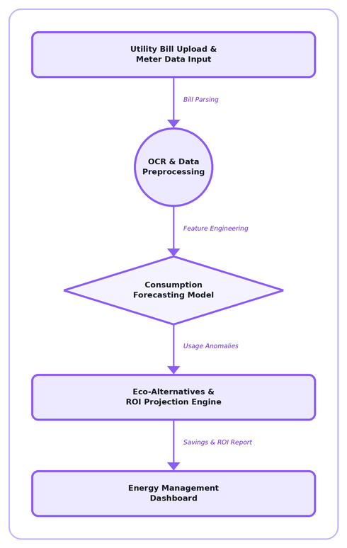
6. Sample Dashboard:


